**ADV. JS**

Q1 Write a program to Show an alert.

-Uploaded on Github.

Q2 What will be the result for these expressions? 1. 5 > 4 2. "apple" > "pineapple" 3. "2" > "12" 4. undefined == null 5. undefined === null 6. null == "\n0\n" 7. 7. null === +"\n0\n" .

-Uploaded on Github.

Q3 Will alert be shown? if ("0") { alert( 'Hello'); } .

- No the alert will not be shown because the 0 indicates false so the code inside curly brace won’t execute.

Q4 What is the code below going to output? alert( null || 2 || undefined );

- Output will be : 2.

Q5 The following function returns true if the parameter age is greater than 18. Otherwise it asks for a confirmation and returns its result: function checkAge(age) {if (age> 18) { return true; }else {// ...return confirm (‘did parents allow you?');}} .

-Uploaded on Github.

Q6 Replace Function Expressions with arrow functions in the code below: Function ask(question, yes, no) { if (confirm(question))yes(); else no(); } ask("Do you agree?", function() { alert("You agreed."); }, function() { alert("You canceled the execution."); } } .

-Uploaded on Github.

Q7 Write the code, one line for each action: a) Create an empty object user. b) Add the property name with the value John. c) Add the property surname with the value Smith. d) Change the value of the name to Pete. e) Remove the property name from the object.

-Uploaded on Github.

Q8 Is array copied? let fruits = ["Apples", "Pear", "Orange"]; // push a new value into the "copy" let shoppingCart = fruits; shoppingCart.push("Banana"); // what's in fruits? alert( fruits.length ); // ?

-No array is not copied in push method. Now fruits = {“Apple”, “Pear”, “Orange”, “Banana”}.

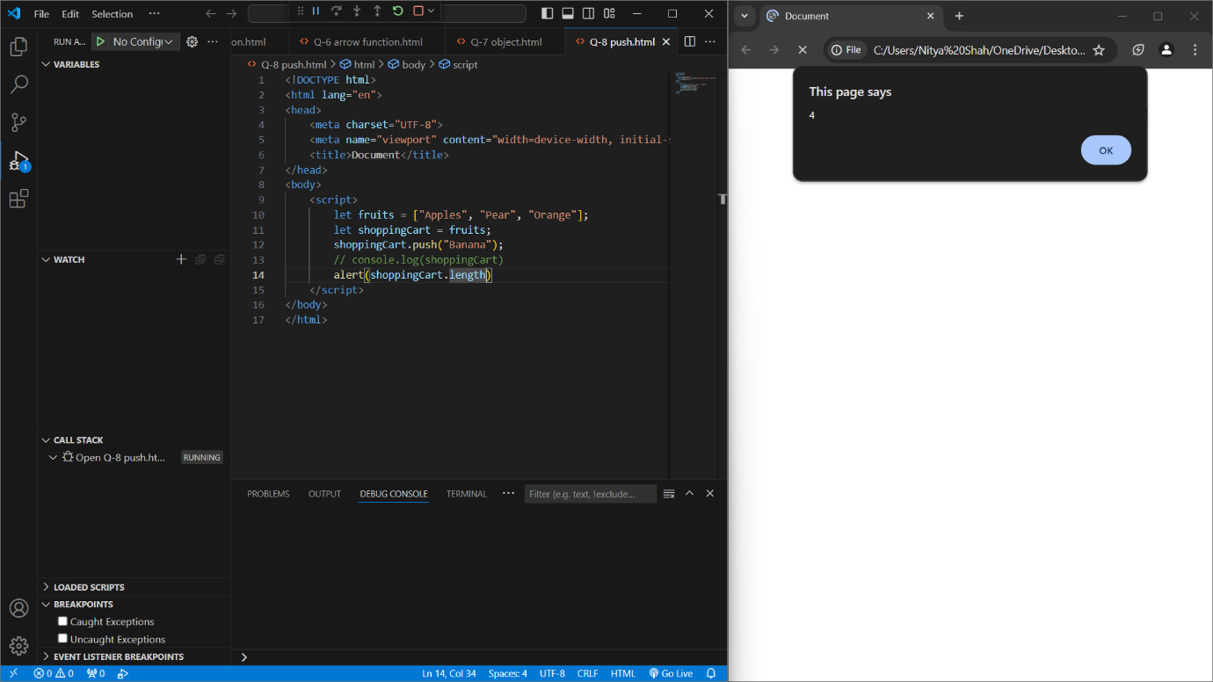

Q9 Map to names let john = { name: "John", age: 25 }; let pete = { name: "Pete", age: 30 }; let mary = { name: "Mary", age: 28 }; let users = [ john, pete, mary ]; let names = /* ... your code */ alert( names ); // John, Pete, Mary .

-Uploaded on Github.

Q10 Map to objects let john = { name: "John", surname: "Smith", id: 1 }; let pete = { name: "Pete", surname: "Hunt", id: 2 }; let mary = { name: "Mary", surname: "Key", id: 3 }; let users = [ john, pete, mary ]; let usersMapped = /* ... your code ... */ /* usersMapped = [ { fullName: "John Smith", id: 1 }, { fullName: "Pete Hunt", id: 2 }, { fullName: "Mary Key", id: 3 } ] */ alert( usersMapped[0].id ) // 1 alert( usersMapped[0].fullName ) // John Smith .

-Uploaded on Github.

Q11 Sum the properties There is a salaries object with arbitrary number of salaries. Write the function sumSalaries(salaries) that returns the sum of all salaries using Object.values and the for..of loop.If salaries is empty, then the result must be 0. let salaries = { "John": 100, "Pete": 300, "Mary": 250 }; alert( sumSalaries(salaries) ); // 650 .

-Uploaded on Github.

Q12 Destructuring assignment We have an object: Write the Destructuring assignment that reads: a) Name property into the variable name. b) Year’s property into the variable age. c) isAdmin property into the variable isAdmin (false, if no such property) d) let user = { name: "John", years: 30}; .

-Uploaded on Github.

Q13 Turn the object into JSON and back Turn the user into JSON and then read it back into another variable. user = { name: "John Smith", age: 35}; .

-Uploaded on Github.

Q14 Create a program to hide/show the password.

-Uploaded on Github.

Q15 Create a program that will select all the classes and loop over and whenever i click the button the alert should show.

-Uploaded on Github.

Q16 Create a responsive header using proper JavaScript.

-Uploaded on Github.

Q17 Create a form and validate using JavaScript.

-Uploaded on Github.

Q18 Create a modal box using css and Js with three buttons.

-Uploaded on Github.

Q19 Use external js library to show slider.

- Uploaded on Github.

Q20 Prevent the browser when i click the form submit button.

-Uploaded on Github.

Q21 What is JSON?

-JSON stands for JAVASCRIPT OBJECT NOTATION which is an open standard file format used for storing and transmitting data.

Q22 What is promises?

- A promise represents the eventual completion ( or failure) of an asynchronous and its resulting value. There are 3 states:

1. Pending
2. Fullfiled
3. Rejected

Q23 Write a program of promises and handle that promises also.

-Uploaded on Github.

Q24 Use fetch method for calling an api <https://fakestoreapi.com/products> .

- Uploaded on Github.

Q25 Display all the product from the api in your HTML page.

- Uploaded on Github.

Q26 Calculate subtotal price of quantity in JavaScript?

-Uploaded on Github.

Q27 What is JavaScript Output method?

-Java script output methods are those methods used to display or even accept the user input.

Q28 How to use JavaScript Output method?

-Uploaded on Github.

Q29 How to used JavaScript Events to do all examples?

-Uploaded on Github.